
ICDC On-Boarding Milestone 4
Create and Utilize Compute Resources

Cognizant Microsoft Business Group
20 North Wacker Drive #530
Chicago, IL 60606

Notice of Confidentiality ©2021 Cognizant Microsoft Business Group All rights reserved.

IS SUBJECT TO THE TERMS OF THE COGNIZANT MICROSOFT BUSINESS GROUP NON-DISCLOSURE AGREEMENT. NEITHER THIS DOCUMENT NOR ITS CONTENTS MAY BE REVEALED OR DISCLOSED TO UNAUTHORIZED PERSONS OR SENT OUTSIDE THE AFOREMENTIONED COMPANY WITHOUT PRIOR PERMISSION FROM COGNIZANT MICROSOFT BUSINESS GROUP

TABLE OF CONTENTS
TABLE OF CONTENTS 2
Preface 2
Landing Resources Deployment 2
Deploy Azure IaaS VM's 3
Deploying (ALB_ Azure Load Balancer for Azure Web App) 7
Set Up IIS on windows servers 10
Test LB 12
Final Thoughts 13

This is a general high-level step-by-step guide for On-Boarding into the ICDC to be used in Conjunction with other training resources

Preface
In this document we will walk through the deployment of landing resources then the deployment of IaaS VM’s and other components required to stand up a simple web app. In this Milestone you will use the skills you have learned from the previous 2 weeks. Azure Networking and Compute resources will be used to create a HA web App.

Landing Resources Deployment

- First, we will need RG's to land resources, We will need 3 RG's, a Networking RG, MGMT/Core RG, and application RG. This is to delineate resources. Feel free to use naming conventions that work in your subscriptions naming environment.
The servers will sit in the Application RG, the shared resources in the Core, and Networking in the networking RG.


- We will now need to create the landing Vnet's, peering's and NSG's to facilitate communication.
- Create a Vnet and NSG for the Application servers to land in, make sure that the NSG has 3389/22 RDP/SSH open as an inbound rule on the VNet.


- Do the same for a MGMT subnet for our Jump box.
- Make sure to peer the application Vnet to the MGMT Vnet
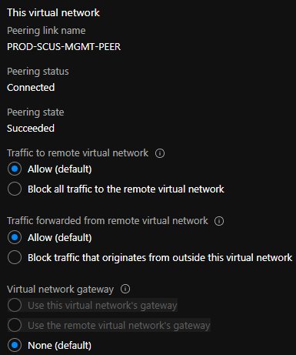

Deploy Azure IaaS VM's
Now that we have the prerequisite infrastructure stood up to facilitate our web application, we can now deploy the servers that the web app will sit on. We will create 4 in total, a Linux machine to test SSH and simulate a DB and then 3 windows servers. 1 a jump box to access the environment, 2 as the "Web App" Servers.

- We will first create the jump box with a public IP (we don’t use public IP's in customer environments, this Is for labing purposes only.)
The Jump

- 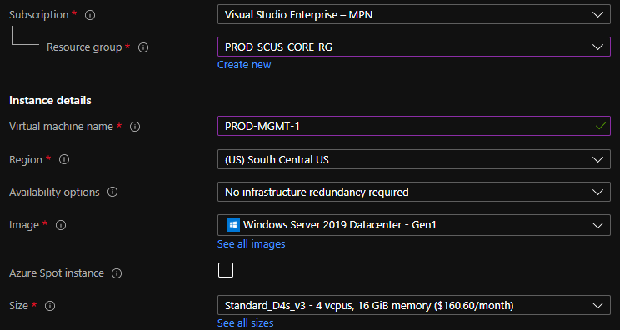
Deploy the jump box into the management (Core) RG.
- 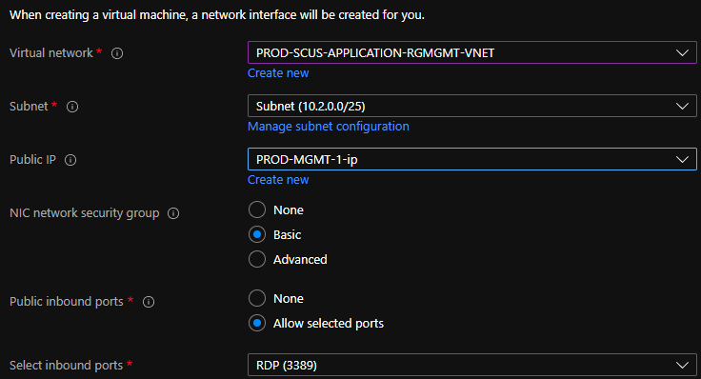Add a public IP so that we can access the machine and thus the other servers in the application Vnet via the peer we implemented in the app-mgmt vnet.

- Availability Sets are set at VM deployment and allow for HA of a VM with 99.99% uptime.
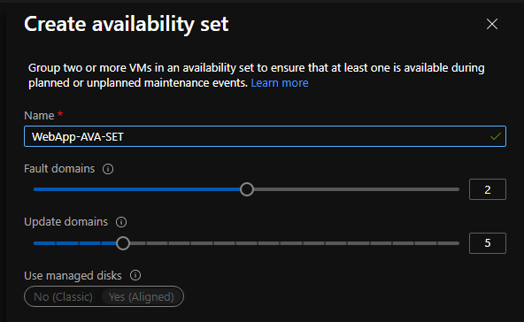
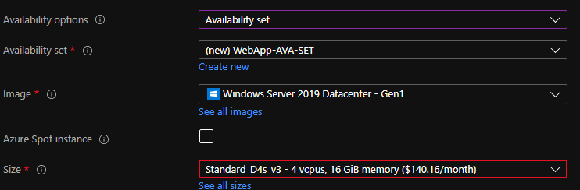
- Now that we have a Jump box in the MGMT VNet that we can access the application servers on we will need to deploy 3 servers to the application VNet.

- First lets deploy the WebApp-1 server, we will deploy it to the application resource group, and the application VNet. I named mine Prod-WebApp-1 but you can fit the server to your naming conventions.

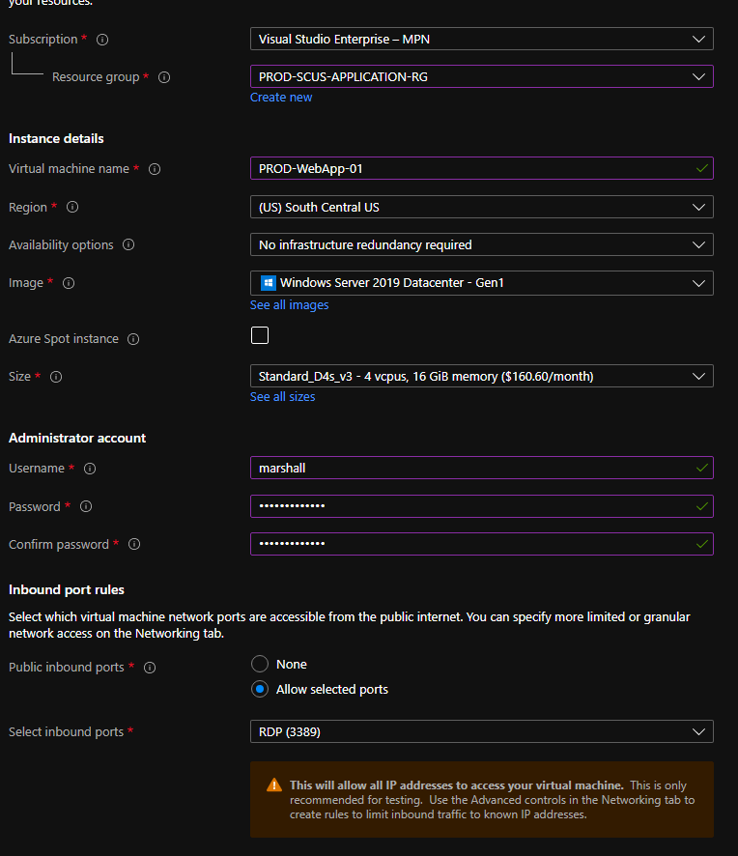

Make sure that we deselect the NSG from the networking pane. We deploy NSGs at the VNet level and do not need them for every VM.
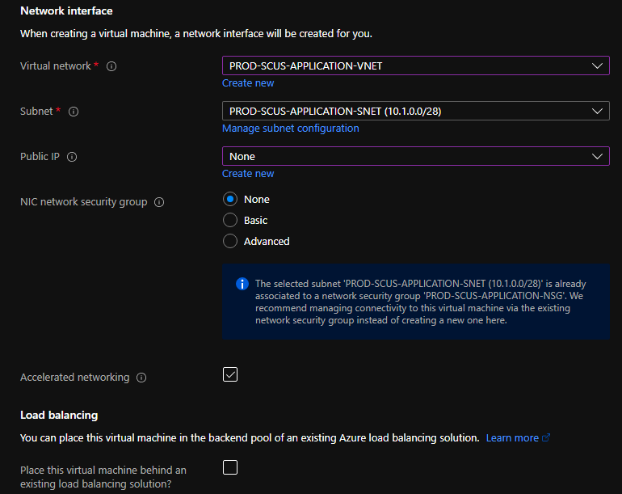

- Once you have the first WebApp server deployed finish deploying the second WebApp and DB server, the naming convention should follow your subscription level standards.

- Once you have the 4 VM's deployed test access by RDP'ing into the jump box in the MGMT network and accessing the other servers.
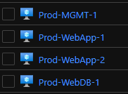

This will require a rule on the NSG associated with the MGMT Vnet to allow RDP
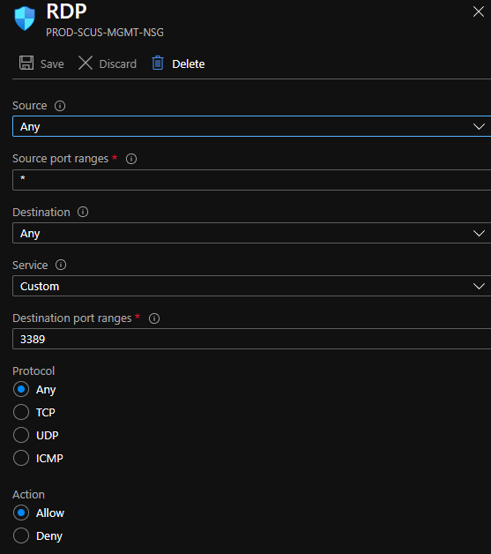

Deploying (ALB_ Azure Load Balancer for Azure Web App)
Once we have the machines stood up and you can access them we need to deploy a public load balancer to allow access to the web application.
An Azure Load balancer is utilized to evenly distribute traffic(Load) across two or more backend resources. In this case we will be using it to balance the load between two IIS servers.
There are two kinds of Load balancer in Azure a public and Azure internal.
Public ALB's balance incoming traffic from the public web and will have a public IP.
Internal ALB's are used to balance traffic internally.
Below is a graphic demonstrating an external LB balancing traffic into a set of VM's that then send traffic on into an internal LB.
Managing Network Load Balancing in Microsoft Azure | Pluralsight – This is a 1 hour course that walks through ALB
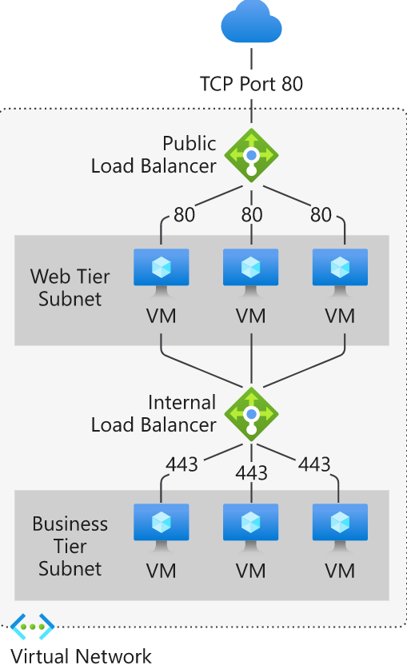

- deploy a public Azure LB into the Core RG where all shared resources are deployed.
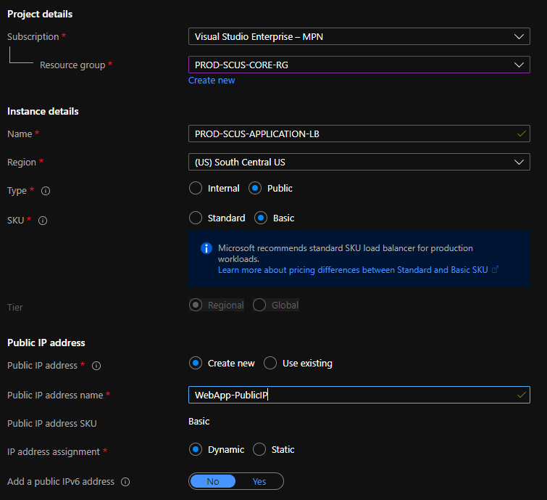
- Create a health probe for the backend pool.
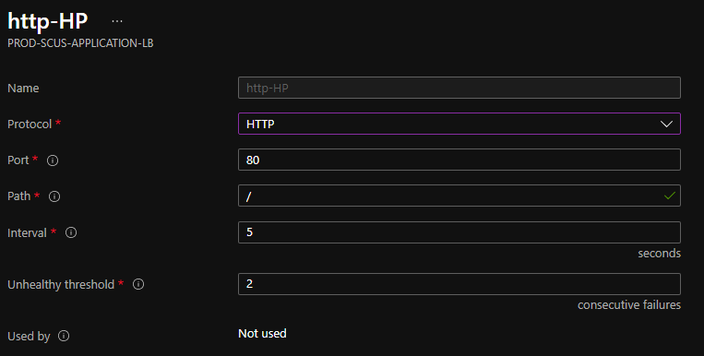
- Create a backend pool with the servers we will use for the WebApp
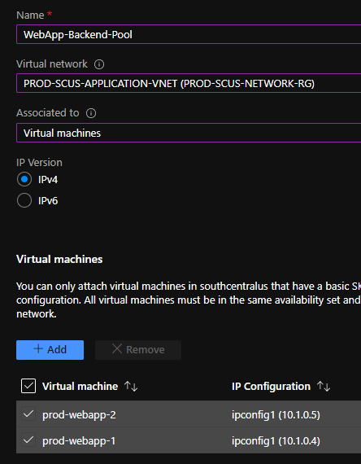
- Create load balancing rule to allow traffic to be balanced once it hits the front end of the LB
Here you will see several options.
You will set the rule for the Incoming port and target port(Backend port), select the backend pool that was just created, set the session persistence this will determine if sessions from a client will be handled by the same VM or if subsequent requests will be handled by any VM in the backend pool.
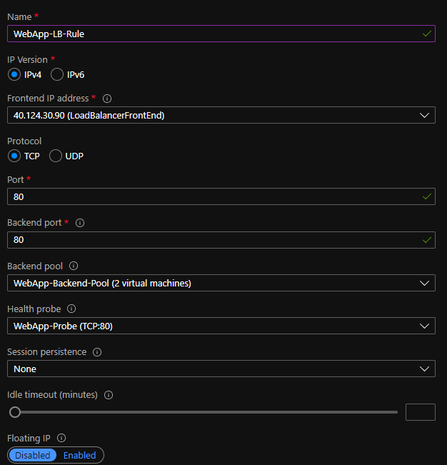

Set Up IIS on windows servers
- Open Server Manager and click Manage > Add Roles and Features. Click Next.
- Select Role-based or feature-based installation and click Next.
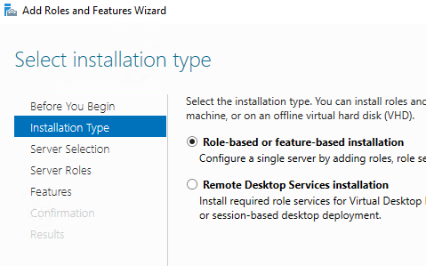
- Select the appropriate server. The local server is selected by default. Click Next.
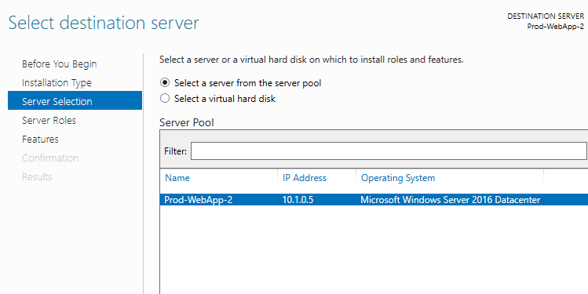
- Enable Web Server (IIS) and click Next.
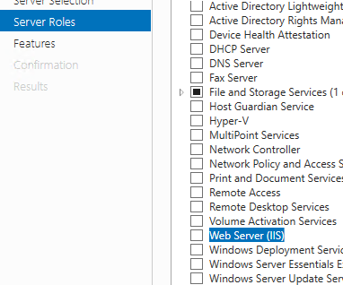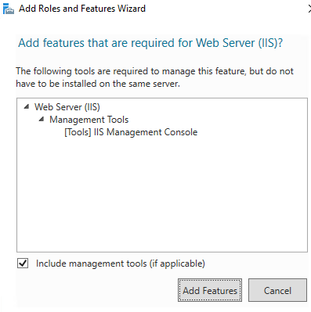
- No additional features are necessary to install the Web Adaptor, so click Next.
- On the Web Server Role (IIS) dialog box, click Next.
- On the Select role services dialog box, verify that the web server components listed below are enabled. Click Next.
- Verify that your settings are correct and click Install.
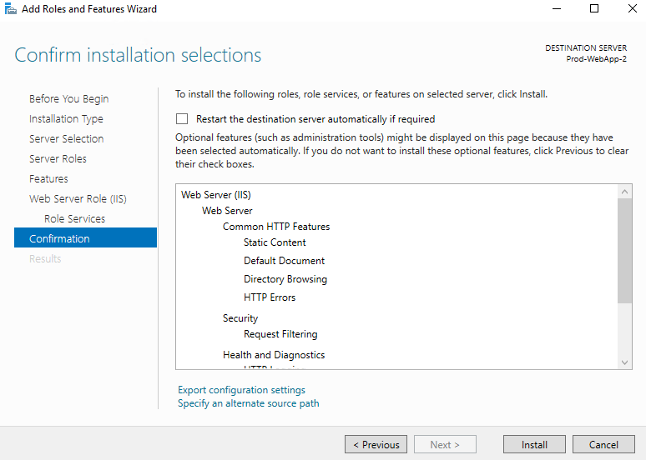
- When the installation completes, click Close to exit the wizard.

- Now that we have IIS installed and the default webpage is pulled up we will want to make a simple change to track the webpage we are accessing, you can either deploy a new website with a note pad or my personal favorite method is just add a text box to the PNG image of the default website.
- First navigate to the file area that the website is stored
- Then open the PNG file
- We are going to add a text box to the PNG with the name of the server we are currently on
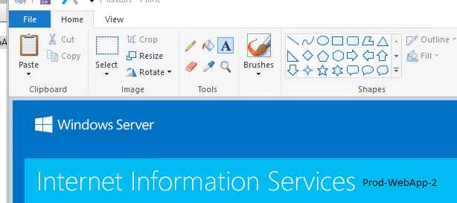

- We can now test this by going to https://localhost/ in IE, it should now appear with the text you just added.

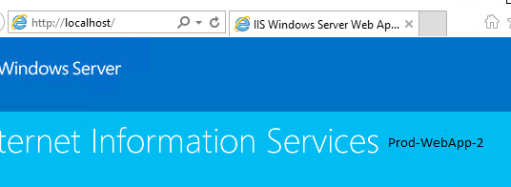
- Complete the steps for the other WebApp server.

Test LB
- Now that we have the web servers set to show separate information as well as a backend rule for port 80, a health probe for port 80, and the appropriate rules for the NSG in place, we can hit the front end of the Azure load balancer from our devices.
- 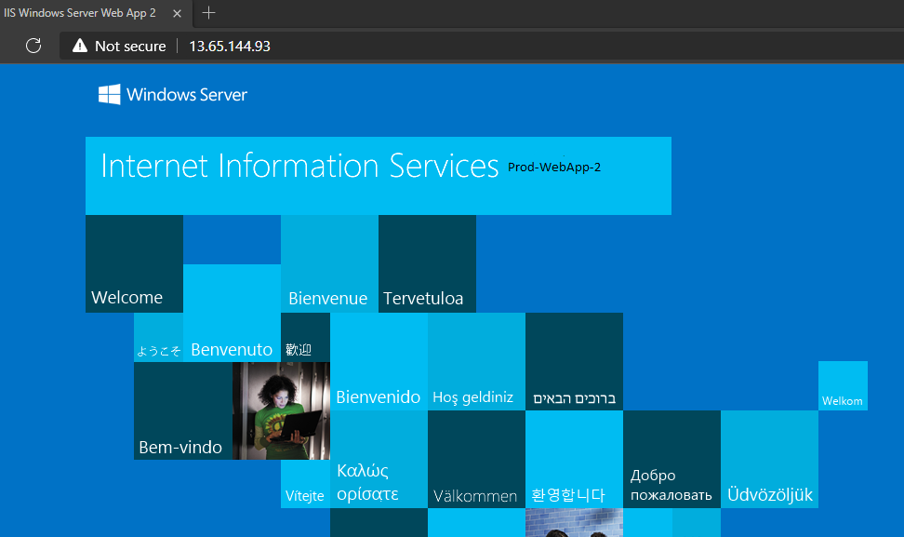
In this case you can see that from the front end of the load balancer I am hitting my second web app server.
If you are unable to hit one server attempt from another machine, or your phone, by default ALB balance 50/50 across the two machines.

Final Thoughts
1. Azure .Compute is the primary resources we work with. As we migrate VM's they are spun up as .Compute In Azure, .Compute is typically supported by other Azure providers such as .Storage, .SQL, etc…

2. In this Document we have deployed Azure VM's then installed IIS and stood up a "Website" behind a public LB. This is a very typical type of web deployment, to continue education from here read into Application Gateway's as well as other technologies.

